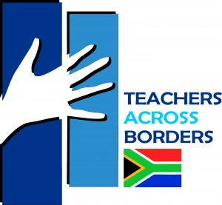

Teachers Across Borders Southern Africa - TABSA - www.tab-sa.org

A professional development opportunity June 29th - July 29th, 2016 for experienced teachers of Math and Science - Grades 6 -12.

The TABSA team of teachers prepares and delivers innovative lessons in week-long workshops based on guidelines in the South African and Swaziland National Curriculum Standards. Browse curriculum content: http://tab-sa.org/cd2014/

For 2016, we have 2 openings on the science team, to join colleagues from Philips Exeter Academy, and Catlin Gabel School. (Physics, Biology, Earth Science)
(The math team (5) is full with colleagues from Punahou School, Phillips Exeter Academy, University of Hawaii, and National Cathedral School)

The entire experience is both rewarding and challenging. This summer (our 16th!) we anticipate working with 400 - 600 teachers in 3 workshops, directly impacting 80,000 students. Attending teachers from southern African rural schools have large class sizes of 40 -100 students, and generally poor facilities. These colleagues give up their winter holidays to attend the workshops so they can benefit their learners. We are in the process of finalizing a contract with the United Nations in Swaziland for a national teacher training program, a partnership TABSA began with UNICEF last year.

Background:
The Bantu Education Act (1953) made it illegal for Black schools to teach or learn Math and Science beyond elementary levels with the reasoning that South Africa’s 30 million Black citizens were destined to be domestic help and manual laborers only. The Bantu Education Act remained in effect for 40 years.

A small group of volunteer teachers from Hawaii, supported by Punahou School, began the quest in 2001 to help fill the 40-year void by working with math and science teachers in rural schools. The pilot program included 100 teachers in 3 provinces under the direction of Professor Kader Asmal, the Minister of Education in a new, democratic, South Africa.

Over the past 15 years, more than 20 NAIS schools and 100+ teachers have served in South Africa, impacting (according to the South African Dept. of Education) over 1.5 million students. In total, 4500 South African (and now Swaziland) teachers have attended the workshops.

See workshop evaluations and teacher reflections on the website: www.tab-sa.org

Participants are responsible for airfare and daily expenses (some of which is offset by grants)

The linked article below appeared in DRUM, an iconic South African magazine.
http://tab-sa.org/wp-content/updir/2012/03/161014DMM081.pdf

If you are interested in the Science team vacancy, please respond by email to TABSA Director Yunus Peer (ypeer@punahou.edu) with a brief resumé.

